SENSOR MODULES FOR CARBON MONOXIDE DETECTION

Akshay Srivastava (Department of Chemical Engineering, Manipal University Jaipur)

The following sensor modules may be considered for the construction of the carbon monoxide detector. These have been short listed on the basis of the following

* Arduino compatibility
* Availability
* Detection range
* Quality of build (under a trusted brand name)
* Price
* Continuous Detection/Minimal Response time
* Portability

Carbon Monoxide Sensor - TGS3870 Gas Sensor

**TGS 3870-B00** is a micro-bead type semiconductor gas sensor for the detection of both **methane** and **carbon monoxide**. Using a micro-bead gas sensing structure, both methane and carbon monoxide can be detected with a single sensor element by **periodic application of two different heater** voltages (high and low). Miniaturization of the gas sensing bead results in a heater power consumption of only 38mW (average). The sensor has low sensitivity to alcohol vapours (a typical interference gas in the residential environment) and has high durability, making the sensor ideal for consumer market gas alarms. A few of the salient features of the sensor are listed below:



Fig. 1.0: Sensor Module

* Miniature size and low power consumption
* High sensitivity and selectivity to both methane

and carbon monoxide (CO)

* Low sensitivity to alcohol vapour
* Long life and low cost

Considering the technical specifications of this sensor, it is best suited for the combined detection of Carbon Monoxide and Methane. The sensitivity characteristics of the sensor for both Carbon Monoxide and Methane are as shown below.

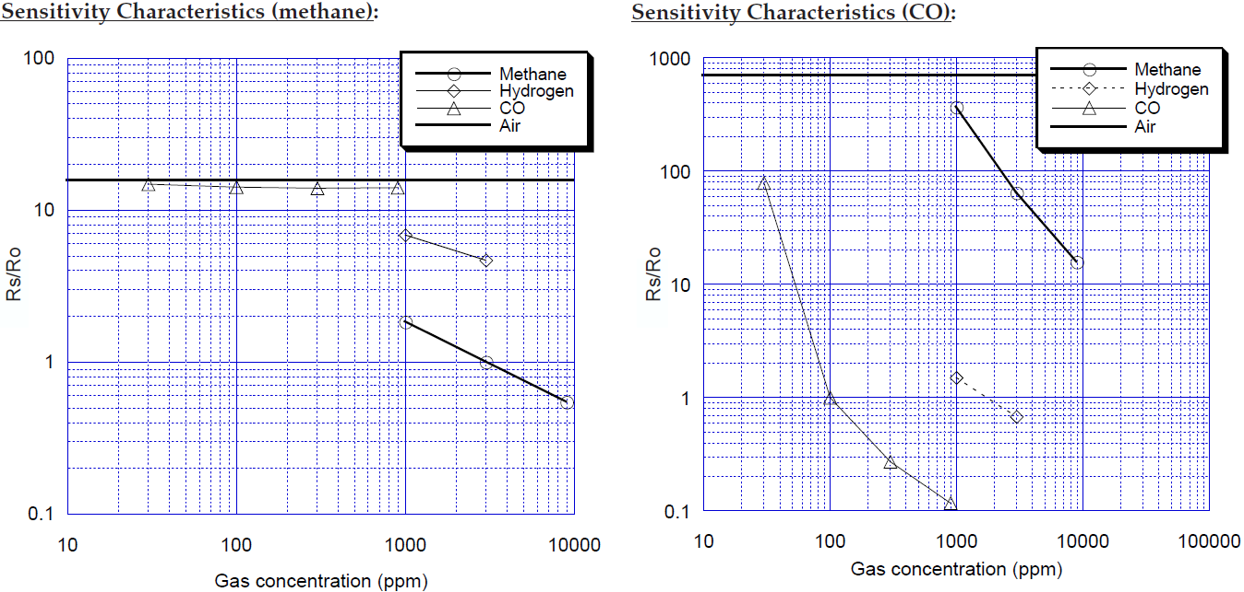

Fig. 1.1: Sensitivity Characteristic of TGS3870 for both methane and carbon monoxide.

In the above diagram the ratio is the ratio of resistance at any given concentration over the resistance at known concentration of the gas. In the case of methane the value of is

sensor resistance in 3000ppm of methane and in case of carbon monoxide it is the sensor resistance in 100ppm of CO. The specification sheet of the sensor is given below:

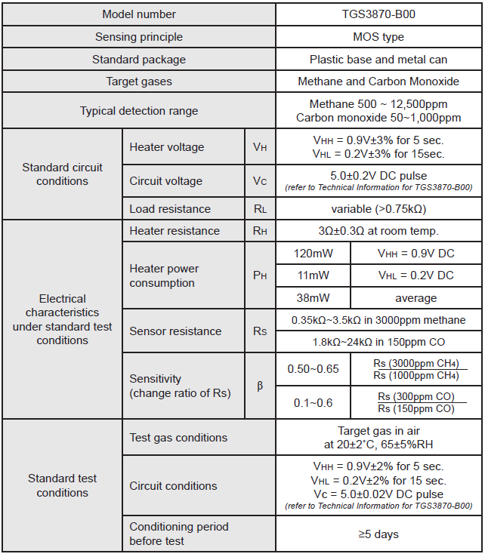

Fig. 1.2: Specification sheet of the sensor.

**The cost of this sensor is Rs.1344 (excluding delivery charges and tax)**

Carbon Monoxide Sensor – TGS5042 A00 Gas Sensor:

**TGS5042** is a battery operable electrochemical sensor which offer several advantages over traditional electrochemical sensors. Its electrolyte is environmentally friendly, it poses no risk of electrolyte leakage, can detect concentrations as high as 1% CO, operates in a range from -40˚ and +70˚C, and it has lower sensitivity to interfering gases. With a long life, good long term stability, and high accuracy, this sensor is the ideal choice for CO detectors with digital display. OEM customers will find individual sensors data printed on each sensor in bar code from, enabling users to skip the costly gas calibration process and allowing for individual sensor tracking. TGS5042 utilizes a standard AA battery-sized package. A few of the salient features of the sensors are listed below.

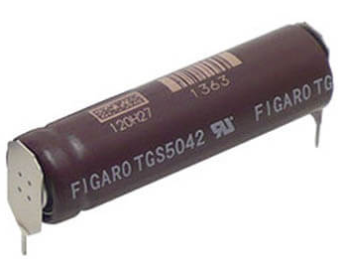

Fig. 1.3: Sensor Module

* -40˚ and +70˚C operation temperatures.
* Highly selective to Carbon Monoxide only
* Long life and low cost
* Detection range of 0-10,000pm CO

Considering the technical specifications of this sensor, it is best suited developing a dedicated CO detector. The sensitivity characteristics of the sensor and the temperature dependency are shown below:

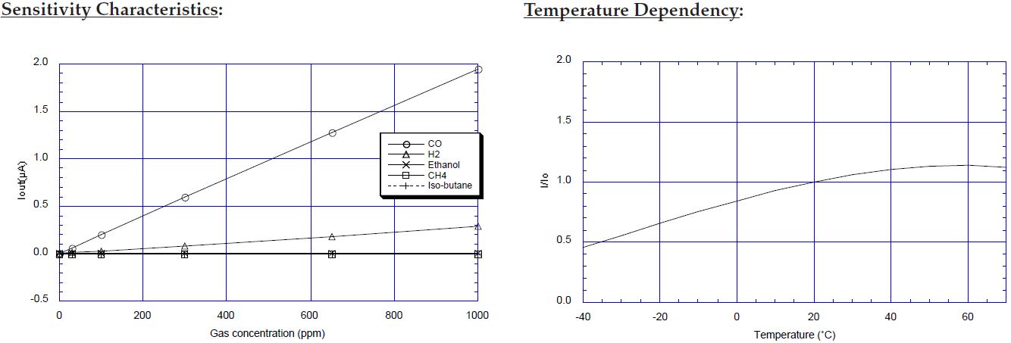

Fig. 1.4: Sensitivity Characteristic of TGS5042 A00 and the temperature dependency characteristic.

The figure above represents typical sensitivity characteristics, all data having been gathered at standard test conditions (see reverse side of this sheet). The Y-axis shows the output current of the sensor (Iout/μA) in each gas. Output current is linear to CO concentration, with a deviation of less than ±5% in the range of 0~500ppm.In the temperature dependency diagram the Y-axis shows the sensor output ratio (I/Io) as defined below. The linear relationship between I/Io and CO concentration is constant regardless of the CO concentration range. ratio is the ratio of current passing through the sensor at any given concentration over the current at known concentration of the gas. Here I = Sensor output current in 400ppm of CO at various temperatures and Io = Sensor output current in 400ppm at 20˚C/50%RH.

The specification sheet of the sensor is given below:

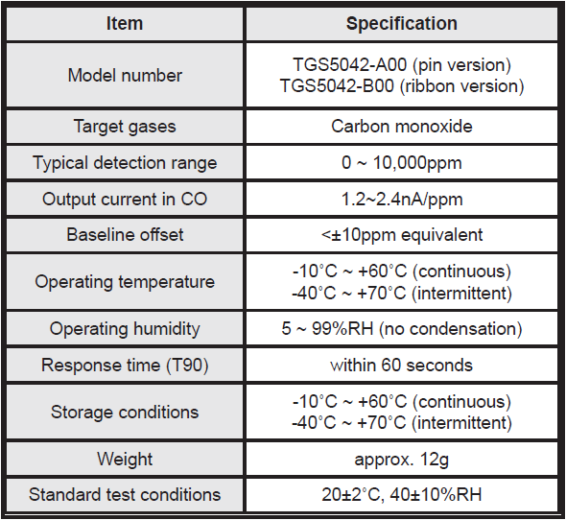

Fig. 1.5: Specification sheet of the sensor.

**The cost of this sensor is Rs.1100 (excluding delivery charges and tax)**

Carbon Monoxide Sensor – TGS5342 Gas Sensor:

**TGS5342** is a battery operable electrochemical sensor which offer several advantages over traditional electrochemical sensors. Its electrolyte is environmentally friendly, it poses no risk of electrolyte leakage, can detect concentrations as high as 1% CO, operates in a range from -40˚ and +70˚C, and it has lower sensitivity to interfering gases. With a long life, good long term stability, and high accuracy, this sensor is the ideal choice for CO detectors with digital display. OEM customers will find individual sensors data printed on each sensor in bar code from, enabling users to skip the costly gas calibration process and allowing for individual sensor tracking. The length of TGS5342 is 60% of the TGS5042. A few of the salient features of the sensors are listed below.

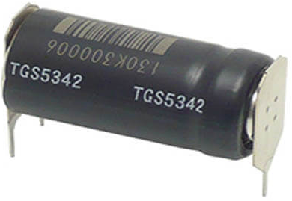

Fig. 1.6: Sensor Module

* -40˚ and +70˚C operation temperatures.
* Highly selective to Carbon Monoxide only
* Long life and low cost
* Detection range of 0-10,000pm CO

Considering the technical specifications of this sensor, it is best suited developing a dedicated CO detector. The sensitivity characteristics of the sensor and the temperature dependency are shown below:

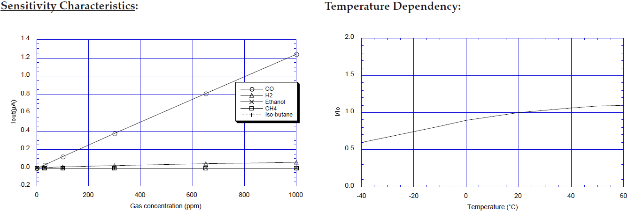

Fig. 1.7: Sensitivity Characteristic of TGS5342 and the temperature dependency characteristic.

The figure below represents typical sensitivity characteristics, all data having been gathered at standard test conditions (see reverse side of this sheet). The Y-axis shows the output current of the sensor (Iout/μA) in each gas. Output current is linear to CO concentration, with a deviation of less than ±5% in the range of 0~500ppm.In the temperature dependency diagram the Y-axis shows the sensor output ratio (I/Io) as defined below. The linear relationship between I/Io and CO concentration is constant regardless of the CO concentration range. ratio is the ratio of current passing through the sensor at any given concentration over the current at known concentration of the gas. Here I = Sensor output current in 400ppm of CO at various temperatures and Io = Sensor output current in 400ppm at 20˚C/50%RH.

The specification sheet of the sensor is given below:

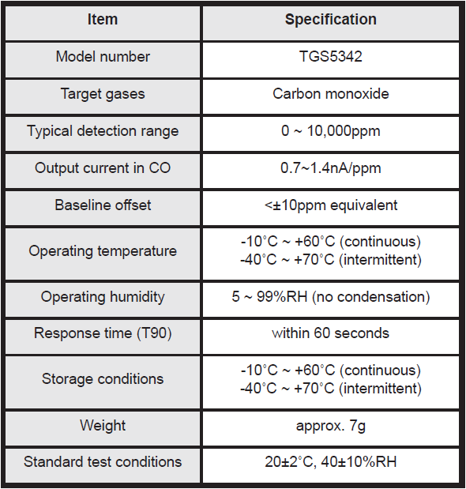

Fig. 1.8: Specification sheet of the sensor.

**The cost of this sensor is Rs.1194 (excluding delivery charges and tax)**

Carbon Monoxide Sensor - FECS40-1000 Gas Sensor:



Fig. 1.9: Sensor Module

FECS40-1000 is a unique electrochemical-type carbon monoxide sensor. Its most notable feature is its unique leak-proof structure, making it ideal for CO monitors and detectors in various fields. A few of the salient features of the sensors are listed below.

* High sensitivity/selectivity to CO
* Quick response to CO
* Linear output
* Long life
* Stable baseline
* Unique leak-proof structure

Considering the technical specifications of this sensor, it is best suited developing a dedicated CO detector. The sensitivity characteristics of the sensor and the temperature dependency are shown below:

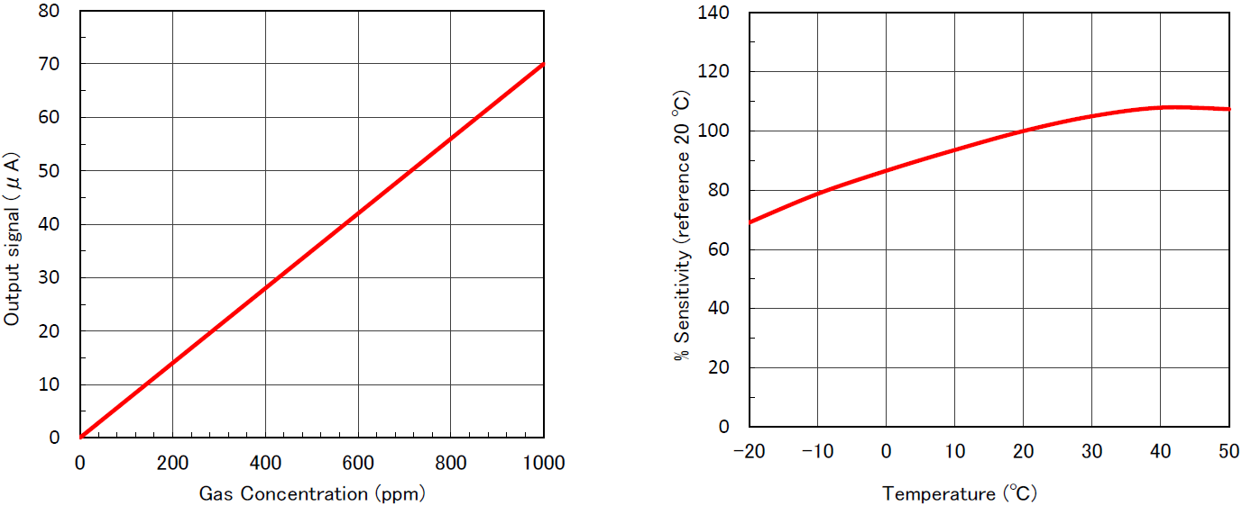

Fig. 1.10: Sensitivity Characteristic of FECS40-1000 and the temperature dependency characteristic.

In the above figure, the output signal varies linearly with the CO concentration. The sensitivity of the sensor is shown as compared to a reference temperature of 20oC.

The specification sheet of the sensor is given below:

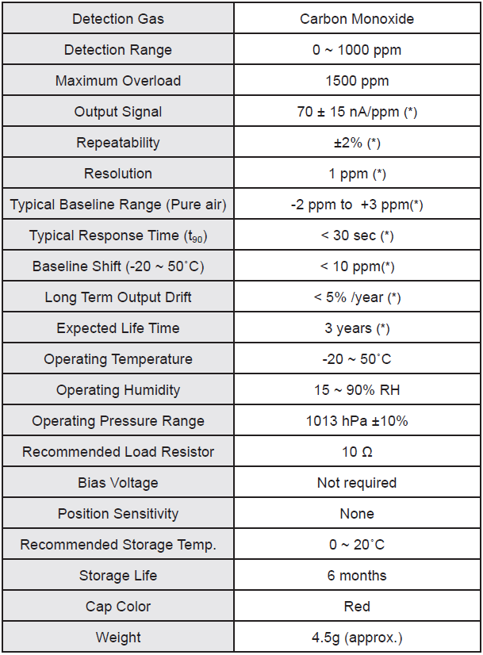

Fig. 1.11: Specification sheet of the sensor.

**The cost of this sensor is Rs.10056 (excluding delivery charges and tax)**